CERCETARI PRIVIND ECHILIBRAREA PENDULULUI INVERS

RESEARCH CONCERNING THE EQUILIBRATION OF THE INVERTED PENDULUM

Autor: Cosma Ioan Adrian
An IV Mecatronica
Donca Radu
An V, Mecatronica

Coordonator: Prof. Besoiu Sorin

Rezumat:

In aceasta lucrare voi incerca sa echilibrez un pendul invers situat pe o sanie ce culiseaza pe un ghidaj, sania fiind actionata de un motor pas cu pas. Scopul lucrarii este mentinerea in stare verticala de echilibru a pendulului invers. Voi prezenta niste consideratii teoretice cu privire la problema pendulului invers iar dupa aceea voi prezenta pe scurt modul in care este posibila echilibrarea pendulului. In continuare va fi prezentat si circuitul care contine partea de control a sistemului

Abstract:

In this essay I will try to equilibrate the inverted pendulum situated on a cart wich glides along a guidage. The cart is driven by a stepper motor. The goal of this essay is mentaining the inverted pendulum in a vertical position for over than 5 seconds. I will present a few considerations concerning the inverted pendulum and some keys in doing this.

Introduction

The inverted pendulum is a classical control problem, which involves developing a system to balance a pendulum. For visualization purposes, this is similar to trying to balance a broomstick on a finger. To study this problem, this project incorporated a full system design including all of the mechanical, hardware, and software design at minimal cost. There are threemain subsystems that compose this design: (1) the mechanical system, (2) the feedback network which includes sensors and a method to read them, and (3) a controller and its interface to the mechanical system. The mechanical design involved building a track, cart, pendulum, and drive mechanism.
The inverted pendulum was designed using a stepper motor and a Cerebot module. The drive mechanism is a stepper motor with a sprocket mounted onto its shaft to pull a rubber belt, which the cart connects to. The feedback network consisted of a linear rotational potentiometer, which is sampled by an analog to digital converter, to measure the angle of the pendulum. There is also a sensor mounted on the cart wich gives us the displacement of it reported to the ends of the guiding system of this cart.
The controller was implemented by an Atmel Mega64L mounted on a Cerebot module which varies the speed of motor. The final system results in a cart that could balance a pendulum for a limited amount of time. This was due to many imperfections in the mechanical system and the inability to model the dynamics of these imperfections along with the calculation limitations of the Atmel Mega64L.

Hardware and software requirements for the project:

Digilent Cerebot Board with programation cable, Stepper motor, Digilent Pmod HB5 H-Bridge Module –two, 6 V Power Supply, Serial connection for programation cable, Digilent Adept Suite, Several connectors, Pmod ADC1 converter, Mcs Electronics-Bascom Avr for chip programming the microcontroller.

Background

The classic control problem of the inverted pendulum is interesting in that it can be solved using a wide variety of systems and solutions. The flexibility of this problem invites those interested in system design, control theory, and just plain problem solving to try and develop a working system. For this project, the motivation was to translate the mathematical models developed in control theory classes into a real-time system.
This design is a full system design including all of the mechanical, hardware, and software aspects at minimal cost.
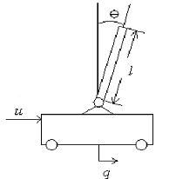
The inverted pendulum is a system that has a cart which is programmed to balance a pendulum as shown by a basic block diagram in Figure 1. This system is adherently instable since even the slightest disturbance would cause the pendulum to start falling. Thus some sort of control is necessary to maintain a balanced pendulum. An ideal controller would keep the pendulum balanced with very little change in the angle, è, or cart displacement, q. Obviously limitations would be imposed based on the actual parameters of the system as well as the method for implementing a controller. Thus designing a controller that is close to ideal is a challenging design problem.

Figure 1- Basic diagram with a pendulum and a generic force being applied to the system

The design of the project

Due to the modularity of this project, the system can be broken up into many subsystems, as shown in Figure 2, that can each be solved in a variety of ways.
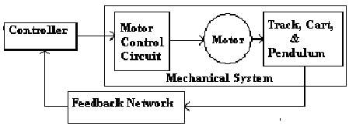
Figure2-
Block
diagram
for the
overall
system

The Mechanical System

The design of a mechanical system for this project involves integrating four main components: (1) the cart, (2) the pendulum, (3) the track, and (4) the mechanism used to move the cart. There are many ways to implement these, though each component is quite dependent on the other three. These components also have to meet some basic requirements such that it is possible to design a controller to balance the pendulum. These requirements are as follows,
• The cart motion needs to be limited to one degree of freedom which is in the horizontal plane
• The pendulum motion needs to be limited to two degrees of freedom, one of which is the
same as the cart’s degree of freedom.
• The friction that impedes the cart and pendulum motion must be reduced as much as possible.
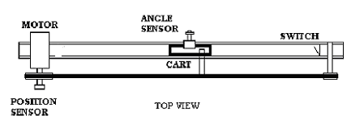
Figure 3-
Simple diagrams of
the track, cart, pendulum and drive mechanism

The axe of the pendulum, for limiting the frictions in the bearing, has two ball bearings. This ball bearings are better than norlam bearings for our application because of the linearity of the friction. The friction force is independent, so, at any angular velocity, the friction is the same. This linearizes a little bit more the system, although there are many non linear components (such as the friction in the potentiometer, the friction between the cart and the two bars).

The stepper motor and it’s control

After searching and testing motors, a safe minimum requirement on the torque turned out to be 1 N-m. For the speed requirement, it was decided that the cart should be able to travel the length of the track in a minimum of one second. With a sprocket of 0.015 meter diameter and track length of arproximatively 0.5meters, a simple calculation shows that the motor should have a speed as follows,
speed=0.5m*1/1sec*60sec/1min*1rev/(0.015π)m=636RPM
The actual control circuit needed for this motor is an H-bridge that can handle a couple Amps.
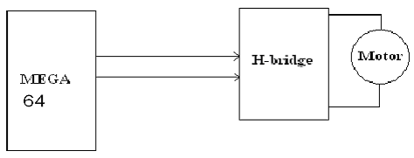
Figure 4- block diagram for control circuit needed to drive the motor

The motor draws 0.25A without a load so adding a load on with instant changes in direction will create current levels of easily 3-4A. The control of the mortor is based on a PID algorithm, the PID algorithm is shortly presented in the following figure.
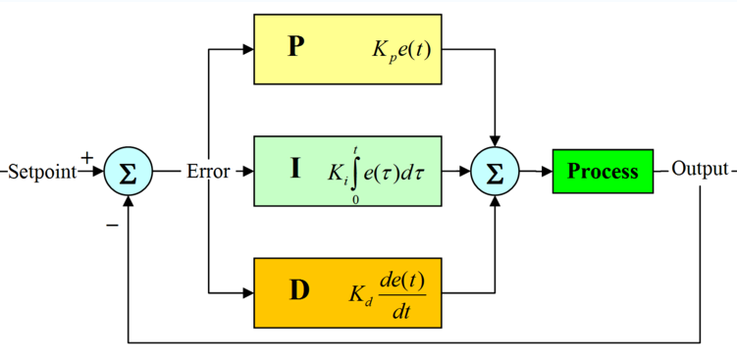
Figure 5 -block diagram for the PID controller
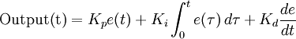

-ecuation of the PID
controller
The Two Sensors

Designing an accurate feedback network is essential to stabilizing the system. Thus the sensors need to relatively noiseless and have a fast response such that the information retrieved from the sensors accurately reflects the state of the system. Determining the variables of the system to measure can be difficult.
One of the easiest solutions for determinating position of the pendulum is to mount the pendulum on a circular potentiometer. Ideally, the potentiometer would have little friction. Though practical potentiometers will have some friction, which could influence the dynamics of the pendulum falling. More friction would slow down the reaction of the pendulum to any of the forces exerted on it, making it easier to balance.
So, the potentiometer is used to get the exact position in witch the pendulum is at a certain moment. This potentiometer is a linear one, with a range of 0-1000ohms. The potentiometer is fixed on the axe of the pendulum.
The second sensor is actually a swich, but not a mechanical one.We need this one for knowing the position of the cart, so that we do not collide the cart with the sides of the sliding mechanism. It is a swich placed at one side of the sliding mechanism. The conditions for not colliding the cart are:
1-at the side with the swich-the cart has to stop when reaching the sensor
2-at the side without swich-after reaching a certain number of steps form the swich beginning, in the other position, the cart will attomatically stop
This solution simplifies the structure, by using only one swich. By eliminating the possibility of collision, we protect the belt from any damages that can occur.

The Cerebot module connected to the entire structure.

For the control of the bipolar stepper motor there are two H-bridges, one for each coil of the motor connected to the Cerebot module. This modules are two HB5. Because we have to know at any moment the position of the pendulum, we connect to the Adc (analog digital converter) the output of the potentiometer. We didn’t use the internal converter of the microcontroller because it can represent the analogic value only on 10 bits. The esternal ADC can represent analog values on 12 bits and that gives us a more accurate answer of the stepper motor to perturbations. The need of the converter is because the output of the potentiometer is an analogic value, and the Atmega64L microcontroller can handle only a digital type of dates. This value given by that potentiometer is compared with the reference value(where the pendulul stays right).
The next picture presents us the whole mechanical structure, wich was designed to be the INVERTED PENDULUM with the cerebot module attached on it:

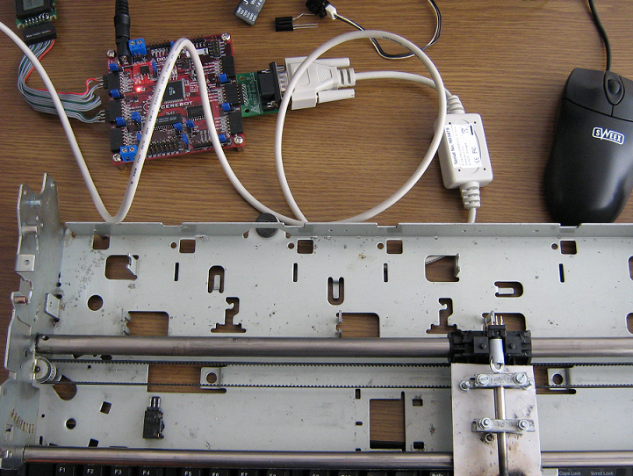
The inverted pendulum with Cerebot attached
Figure 6.

The cerebot module is also the most important part of the project because the progmam that gouvernates the process is implemented in this part.

Discussion

First off, the cart was able to balance the pendulum for about 3-5 seconds completely on its own before getting to close to the edge of the track. As the cart approached the edge of the track, a small “tap” on the pendulum in the other direction, would allow the cart to balance the pendulum longer. The inability to balance a pendulum for an extended period of time can possibly be attributed to many different factors.. Another factor that could be limiting the success of the design is the model of the system. Since the system is quite complex mechanically, there are many parts that interact with each other which could lead to mismodeled and unmodeled dynamics. The system also has many imperfections such as the pendulum is not completely constrained to just two degrees of freedom. Another factor that could cause some error is that the sampling rate is slow enough that it may not be possible to implement a working controller using a continuous time design.
Overall the project can be considered a success. Despite the fact that the main goal of the project was not reached- the cart was unable to balance the pendulum for an extended period of time- the foundation is laid for future research. Many requirements were met such that a working mechanical system was developed along with a control circuit and an accurate feedback network.
The system would need to modified to reduce some of the imperfections and increase the torque and speed of the motor The most beneficial aspect of this project was that it gave exposure to a full system design. The experience gained from developing each of the subsystems given the constraints they imposed on each other and then integrating them together proved to be invaluable.

- References
- [1] Digilent Cerebot Board Reference Manual
- http://www.digilentinc.com/Data/Products/CEREBOT/CEREBOT-rm.pdf
- [2] Designing the inverted pendule
- http://www.livingcontrolsystems.com/demos/inverted_pendulum/inverted_pendulum.pdf
- [3]Potentiometers
- http://en.wikipedia.org/wiki/Potentiometer
- [4] Stepper Motor
- http://en.wikipedia.org/wiki/Stepper_motor
- [5]PID control
- http://en.wikipedia.org/wiki/PID_control
- [6] www.google.com

